**STAT 455 Homework 01 – SAS Code**

Martha Eichlersmith

2019-10-10

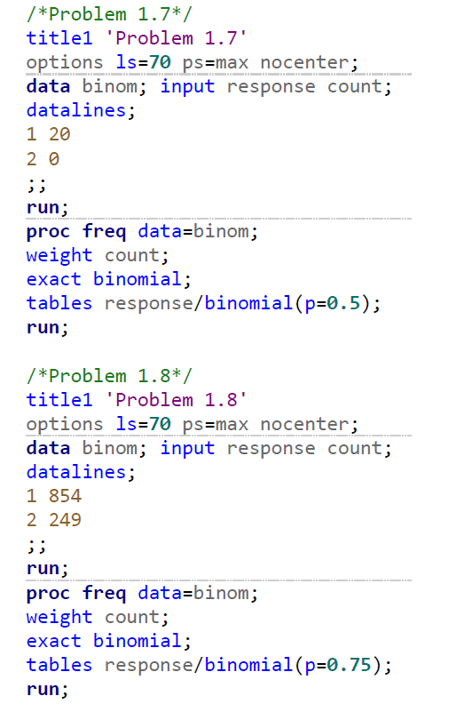

**STAT 455 Homework 01 – SAS Results**

Martha Eichlersmith

2019-10-10

Problem 1.7 options ps=max nocenter

The FREQ Procedure

| **response** | **Frequency** | **Percent** | **Cumulative Frequency** | **Cumulative Percent** |
| --- | --- | --- | --- | --- |
| **1** | 20 | 100.00 | 20 | 100.00 |

| **Binomial Proportion** | |
| --- | --- |
| **response = 1** | |
| **Proportion (P)** | 1.0000 |
| **ASE** | 0.0000 |
| **95% Lower Conf Limit** | 1.0000 |
| **95% Upper Conf Limit** | 1.0000 |
|  |  |
| **Exact Conf Limits** |  |
| **95% Lower Conf Limit** | 0.8316 |
| **95% Upper Conf Limit** | 1.0000 |

| **Test of H0: Proportion = 0.5** | |
| --- | --- |
| **ASE under H0** | 0.1118 |
| **Z** | 4.4721 |
| **One-sided Pr > Z** | <.0001 |
| **Two-sided Pr > |Z|** | <.0001 |
|  |  |
| **Exact Test** |  |
| **One-sided Pr >= P** | <.0001 |
| **Two-sided = 2 * One-sided** | <.0001 |

|  |
| --- |
| ***Sample Size = 20*** |

Problem 1.8 options ps=max nocenter

The FREQ Procedure

| **response** | **Frequency** | **Percent** | **Cumulative Frequency** | **Cumulative Percent** |
| --- | --- | --- | --- | --- |
| **1** | 854 | 77.43 | 854 | 77.43 |
| **2** | 249 | 22.57 | 1103 | 100.00 |

| **Binomial Proportion** | |
| --- | --- |
| **response = 1** | |
| **Proportion (P)** | 0.7743 |
| **ASE** | 0.0126 |
| **95% Lower Conf Limit** | 0.7496 |
| **95% Upper Conf Limit** | 0.7989 |
|  |  |
| **Exact Conf Limits** |  |
| **95% Lower Conf Limit** | 0.7484 |
| **95% Upper Conf Limit** | 0.7986 |

| **Test of H0: Proportion = 0.75** | |
| --- | --- |
| **ASE under H0** | 0.0130 |
| **Z** | 1.8601 |
| **One-sided Pr > Z** | 0.0314 |
| **Two-sided Pr > |Z|** | 0.0629 |
|  |  |
| **Exact Test** |  |
| **One-sided Pr >= P** | 0.0329 |
| **Two-sided = 2 * One-sided** | 0.0658 |

|  |
| --- |
| ***Sample Size = 1103*** |